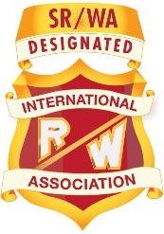
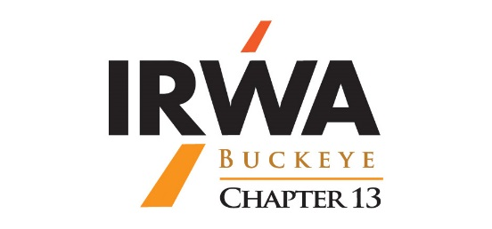
International Right-of-Way Association
Chapter 13
(Buckeye Chapter)
Survey/Engineering Day
September 14, 2021
Live at the Der Dutchman, Plain City, Ohio
Virtual option available for those that cannot attend in person.
8:00 AM to 8:30 AM Registration and Networking – Coffee and donuts
8:30 AM to 9:00 AM IR/WA General Membership Meeting – Rick Nichols, P.S., IR/WA Chapter 13 President, Presiding
Seminar Coordinator: Richard D. Nichols, P.S., McGill Smith Punshon, Inc.
9:00 AM to 12:00 PM Railroad Real Estate and Real Property Rights- Gary R. Kent, P.S. Integrated Services Director, Schneider Geomatics
Scheduled Break at 10:30 AM
12:00 PM to 1:00 PM Lunch – 1 Hour – Opportunities for networking
1:00 PM to 2:00 PM Managing your Survey Contractor- Terry Rowe, RPLS, LSLS, PMP, Survey Operations Manager, BOWMAN Consulting Group, LTD.
2:00 PM to 2:10 PM Break – 10 Minutes
2:10 PM to 3:10 PM Evolving Survey Technologies – Impacting Workflows - Kevin Chappell, Principal – Director of Surveys, BOWMAN Consulting Group, LTD.
3:10 PM to 3:20 PM 50/50 Raffle Winner – Pie for Your Thoughts! Winner
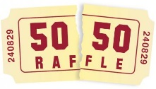
3:20 PM Adjournment

AM Session  Attendance Confirmation | PM Session  Attendance Confirmation

Name:___________________________________________________________
Org: ____________________________________________________________
Email: ___________________________________________________________

