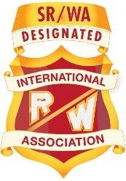
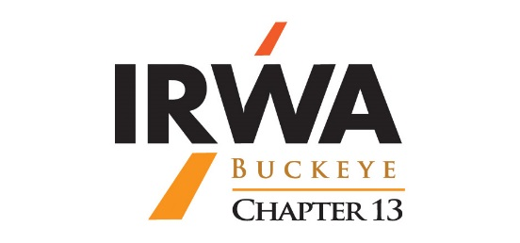
International Right-of-Way Association
Chapter 13 - Buckeye Chapter
Appraisal Day Seminar
May 11, 2021
On-Line Microsoft Teams Meeting
8:30 AM to 9:00 AM IR/WA General Membership Meeting – Kevin Jennings, IR/WA Chapter 13 Presiding President
Seminar Coordinator: Gerald A. Tout - Martin + Wood Appraisal Group, Ltd.
9:00 AM to 10:00 AM Wetland and Stream Regulations in Ohio - Permitting Mechanisms in Ohio that Allow Regulated Lands to be Utilized for Various Uses: Brandon Beck, – Section 401 Reviewer for ODOT Projects, Ohio Environmental Protection Agency
10:00 AM to 10:50 AM Review and Discussion of State ex rel. New Wen, Inc. v. Marchbanks (ODOT) – “Point of Access” and Compensation: Corinna V. Efkeman – Associate Assistant Attorney General – Executive Agencies Section, Transportation Unit, Office of Ohio Attorney General Dave Yost
10:50 AM to 11:00 AM Break – 10 Minutes
11:00 AM to 12:00 PM Oil and Gas Valuation for Eminent Domain Acquisitions: Wayne L. Kelley, Managing Director, RSK [UK] Limited
12:00 PM to 1:00 PM Lunch – 1 Hour
1:00 PM to 1:50 PM Eminent Domain Litigation Support Appraisal Review Case Study: Jefferson L. Sherman, MAI, AI-GRS – President, Sherman Valuation & Review, LLC.
1:50 PM to 2:00 PM Break – 10 Minutes
2:00 PM to 3:00 PM The Impacts of COVID-19 on Real Estate: Kyle Driscoll, MAI, - Director – Midwest & Northeast, Right of Way Practice Leader, CBRE, Inc., Valuation & Advisory Services
3:00 PM Adjournment – Kevin Jennings, IR/WA Chapter 13 President

Attendance Certificates to be e-mailed to registered attendees.

