INTERNATIONAL RIGHT OF WAY ASSOCIATION
FALL FORUM REGIONS 5 AND 4
OCTOBER 1-2, 2021- IN CLEVELAND OHIO
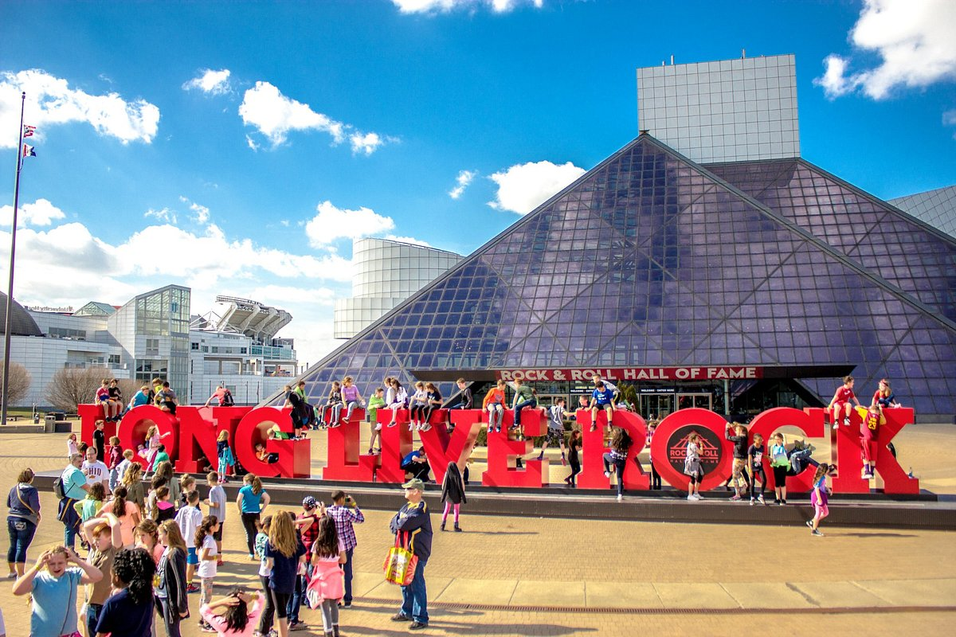

Chapter 13 is proud to host a joint forum for the two finest Regions in the IRWA
We will be meeting at the Hilton Downtown Cleveland which will be the host hotel for CLE 22 the INTERNATIONAL RIGHT OF WAY ASSOCIATION’S Education Conference June 5-8, 2022! Come now and get a preview of this wonderful location!
Rooms for this Forum are $189.00 plus tax (single or double) and can be reserved by using this link: https://book.passkey.com/go/IRWA21
The Forum meeting will begin: Friday October 1 at 1:00PM -5:00PM*
Saturday October 2 at 8:00AM-1:00PM
Breakfast and lunch provided
Tour of Cleveland sights 1:00PM ending at the Rock & Roll Hall of Fame!
The room block at the Hilton includes rooms for Friday and Saturday
With a limited number of rooms available on Thursday

Registration for the Joint Region 4 and 5 Forum
Cost for Forum $85.00 per person
Name: ________________________________________________
Chapter________ Officer ___________________
Cell phone __________________________
Email_______________________________________________

Send registration to: Jenn Murray, Chapter 13 Treasurer
86 Cherry Blossom Road SW
Pataskala OH 43062

Or using square: irwachp13.square.site

*See additional flyer for a GREAT Friday night activity
Also
*See additional flyer for a very SPECIAL Relocation Assistance program for Friday morning.

